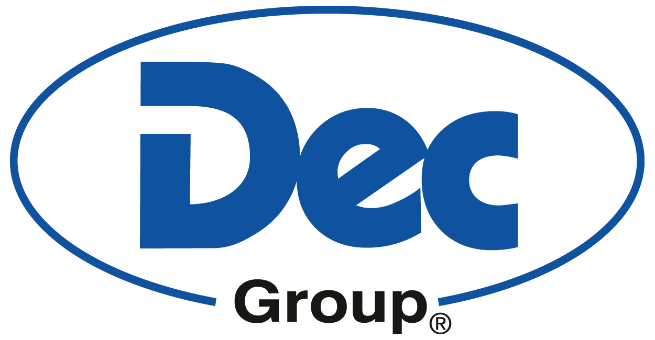

Press Release

Dec Group appoints PCS as Northeast US agent

December 4, 2020
Ecublens, Switzerland: –Dec Group has appointed one of North America’s leading containment and process representatives, Process Control Solutions (PCS) as a supplementary agent for the Northeastern United States.
PCS will carry the full range of Dec Group’s present integrated high containment manufacturing and packaging solutions based on their PTS Powder Transfer System® handling, filling, blending, micronizing and barrier technology.

Supply and support
From its sites near Boston and Philadelphia, PCS will be able to supply and support Dec systems in the states of Connecticut, Delaware, Maine, Maryland, Massachusetts, New Hampshire, New Jersey, New York, Pennsylvania, Rhode Island, and Vermont, along with Washington DC.
The agreement is driven by rising demand for Dec solutions across North America.
A key factor in selection of PCS to represent Dec Group was the American company’s commitment to providing a total service, recognizing the need of in-depth understanding of Dec systems and engineering to be able to develop tailored equipment solutions to fit end-users’ projects and budget.
Process Control Solutions is able to undertake detailed project planning, sometimes years ahead of installation, supported by Dec’s highly experienced technical sales team.

About Dec Group
Dec (Dietrich Engineering Consultants) Group is a leading global provider of contained powder handling systems and is recognized as a world-leading expert in process containment technologies. It has been supplying the pharmaceutical, chemical, food and cosmetic industries for more than 30 years.
Headquartered near Lausanne, Switzerland, Dec Group has a global presence with subsidiaries and agents in more than 30 countries including subsidiaries in the UK, Ireland, Germany, Poland, the Netherlands, India, China and the USA.
In excess of 600 companies worldwide have successfully integrated more than 9’000 Dec systems into their production sites. These include a wide range of patented products that enhance safety, hygiene, containment, reliability and productivity in powder handling.
Dec offers innovative approaches across the range of powder handling and process containment applications, including transfer, micronizing, filling/emptying, sampling, blending, dosing, aseptic solutions, milling, isolators and advanced cleaning (CIP/SIP) features.
Further information at: https://www.dec-group.net

About PCS Process Control Solutions

With sites at Shrewsbury MA and Yardley PA, Process Control Solutions (PCS) are containment specialists, who carries a broad portfolio of products and systems from leading manufacturers that help pharmaceutical, industrial and life science companies conduct a broad range of applications from process manufacturing and pharmaceutical production to laboratory testing and environmental research.
PCS provides various installation services including receiving, uncrating, rigging, installation, start up and user training for all of equipment sold, along with on-site warranty and post warranty repair, preventative maintenance and calibration services.
Further information at: https://www.process-info.com

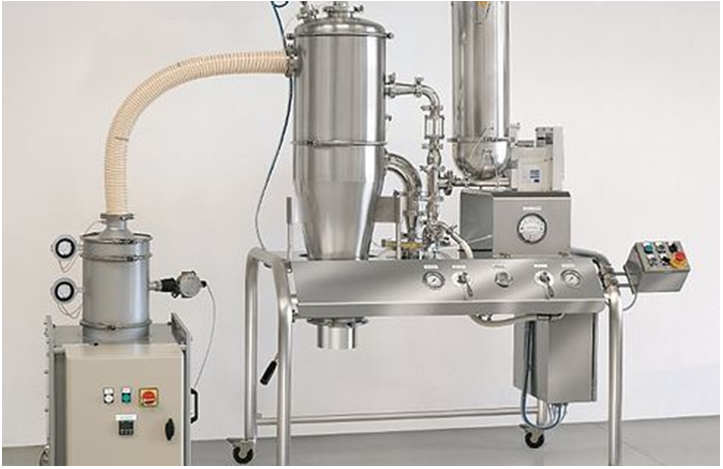
Process Control Solutions will now add Dec Group systems such as DecJet 150 pilot scale micronizing jet mill to its range of leading-edge contained process solutions

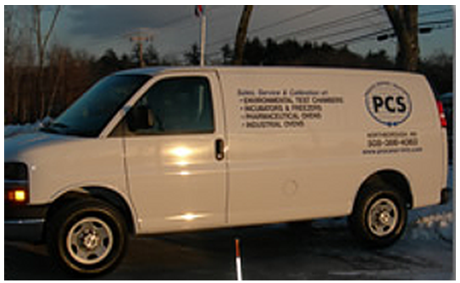
PCS prides itself on its network of
field agents and on-site support

